|  |  |
| --- | --- |
| **Team Member Name:** | **Team Member UID:** |
| Manish Jadhav | 2023301005 |
| Mayur Solankar | 2023301018 |

|  |  |
| --- | --- |
| **EXPERIMET NO:** | 3 |
| **AIM:** | Class Diagram for Hostel Management System |

|  |  |
| --- | --- |
| **Problem Statement:** | The Hostel Management System (HMS) project addresses the challenges faced in efficiently managing hostels in today's world. With a focus on enhancing student satisfaction, the HMS aims to provide a comprehensive solution. It offers user management for administrators, students and visitors, simplifies room booking, facilitates smooth check-in/check-out processes, manages billing and payments, monitors room availability, maintains student profiles, and provides reporting and analytics tools. The system ensures data security and privacy compliance while offering a user- friendly interface accessible via a web app. By automating administrative tasks and optimizing room management, the HMS benefits hostel owners, while also improving the student experience  and modernizing hostel operations. |
| **Noun/Noun Phrases:** | Student, Hostel Administrator, Users, Hostel, Staff, Rooms, Payment, Transaction, Allotment |
| **Classes:** | Hostel, Rooms, Student, Payment, Transaction, Allotment |
| **Verb Phrases:** | 1. Hostel Administrator checks room if available 2. Hostel Administrator allocates the room to student 3. Student makes profile 4. Student makes payment 5. Specific room allocate to student 6. Students can add their check in / check out timings |

|  |  |
| --- | --- |
|  | 7) Student can update his/her profile |
| **Relations:** | 1. Transaction: This class records financial transactions for payments. 2. Users: Represents all system users, including students and administrators. 3. Student: Contains student information, including studentID and contact details. 4. Admission: Manages student admissions, connecting students to rooms and payments. 5. Hostel Administrator: Interacts with the system for room management and oversight. 6. Rooms: Represents individual hostel rooms with attributes like roomNumber and capacity. 7. Payment: Records financial transactions associated with students. 8. Allotment: Links students to their assigned rooms for accommodation management. |

**Diagram:**

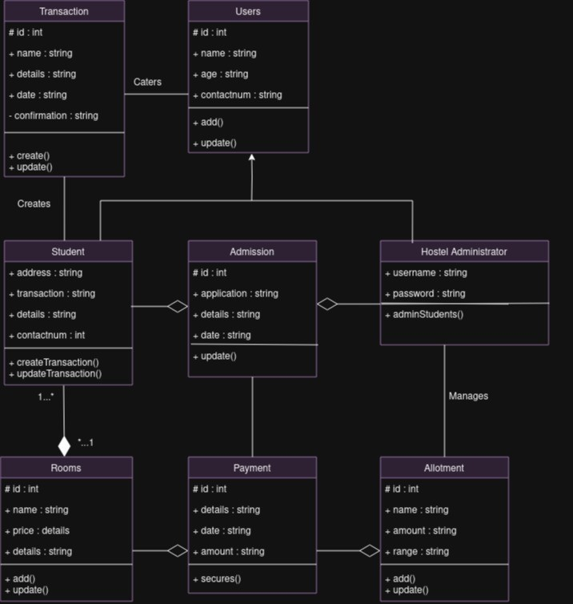

|  |  |
| --- | --- |
| **Conclusion:** | In summary, the Hostel Management System class diagram, incorporating classes such as "Transaction," "Users," "Student," "Admission," "Hostel Administrator," "Rooms," "Payment," and "Allotment," serves as a visual blueprint for designing a robust and efficient hostel management system. It defines the core entities and their relationships, enabling effective management of student admissions, room allocations, payments, and user interactions within the system. This class diagram lays the foundation for building a comprehensive and user-friendly Hostel Management System to streamline hostel operations and enhance the overall hostel experience. |